**Chapter 3 - Cell**

**All Lectures Uploaded on YouTube:**

[**https://tinyurl.com/fkm9-biology**](https://tinyurl.com/fkm9-biology)

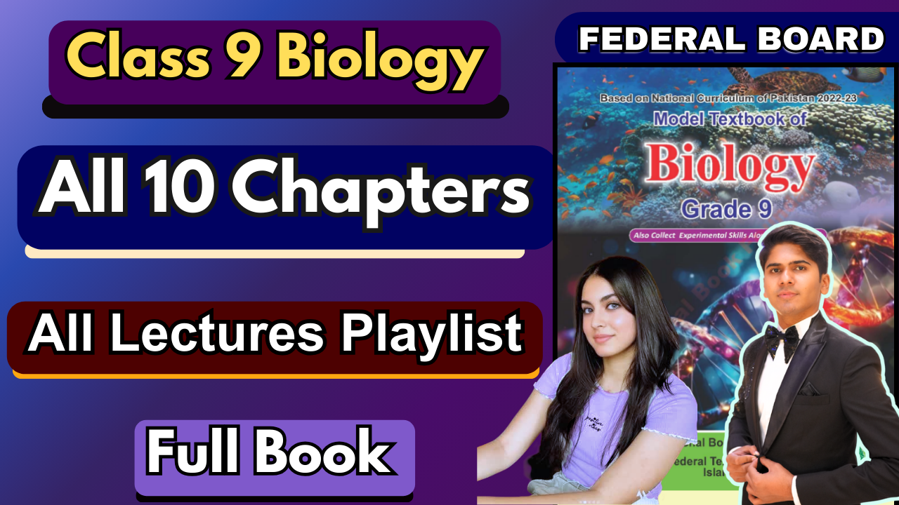

**MCQS:**

1. B
2. D
3. D
4. C
5. B
6. B
7. D
8. C
9. D
10. D
11. B

**Short Question Answers:**

1. Mitochondria are the powerhouse of the cell because they generate most of the cell’s **ATP**, which is used as the **energy currency** of the cell.
2. RBCs are most suitable for oxygen transport because of their adaptations/specialization, which include the shape of the cell biconcave discs, increasing their surface area, which transports oxygen. Secondly, RBCs do not have any cell organelles, leading to an even greater surface area.
3. a. Exchange of gases: They have **stomata** or guard cells, which contain pores that allow gaseous exchange by opening when gas exchange is going on and closing when its done.

b. Absorption of water and minerals: **Root hair cells** are adapted in a way that increases their surface area for water and mineral absorption.

1. A. Cell activities are controlled by the nucleus- 4

B. Glycolysis or photosynthesis

C. Part 1 is the cell wall, so if it is removed cell’s osmotic pressure would be decreased and overfilling part 3- vacuole will lead to turgidity and the absence of cell wall would lead to the cell bursting.

1. a) E—nucleolus

F —nuclear pore

b) The **nuclear pore** is a complex structure in the nuclear envelope that controls the movement of molecules between the nucleus and the cytoplasm. It allows the **selective exchange** of materials such as RNA and ribosomal subunits out of the nucleus and proteins into the nucleus.

c) The nucleolus is responsible for the **formation of ribosomes**, which are cytoplasmic organelles. It synthesises ribosomal RNA (rRNA) and combines it with proteins to produce ribosomal subunits.

d) During cell division, specifically in prophase of mitosis, the nucleolus disappears. This happens because the cell stops producing ribosomes temporarily, and the nuclear envelope also breaks down. The components of the nucleolus disperse into the cell. After the chromosomes are separated and the nuclear envelope reforms during telophase, the nucleolus reappears in each daughter nucleus, and ribosome production resumes.

1. **Red Blood Cells (RBCs):** They have a biconcave disc shape, which increases surface area for efficient oxygen exchange and allows them to easily squeeze through narrow capillaries.  
   **Nerve Cells (Neurons)**: Their long, branched shape helps in transmitting electrical signals over long distances and connecting with many other neurons or muscles.  
   **Muscle Cells:** These cells are long and cylindrical, allowing them to contract and relax efficiently, which is essential for movement and force generation.
2. According to the Fluid Mosaic Model, the cell membrane is made up of a fluid phospholipid bilayer in which **proteins are embedded** like a **mosaic**. The **phospholipids** make up the "**fluid**" part, allowing movement within the layer, while the proteins and other components scattered throughout form the "mosaic" part, giving the membrane its dynamic and flexible nature.
3. The following structures are present in all cells of all kingdoms.

**Cell Membrane** – Controls what enters and leaves the cell.

**Cytoplasm** – Jelly-like fluid where cell activities occur.  
**Chromosome** – Carries genetic information (DNA).  
**Ribosome** – Synthesises proteins.

1. In animals, mature **red blood cells (RBC’s)** do not have a nucleus. This adaptation creates more space for haemoglobin, allowing it to carry more oxygen. Though they cannot divide or repair themselves, they function efficiently by circulating oxygen until they are replaced. In plants, mature **sieve tube cells** (part of the phloem tissue) also lack a nucleus. These cells transport sugars and other nutrients. They rely on companion cells, which are closely connected and contain a nucleus. Companion cells help control and support the metabolic functions of sieve tube cells through plasmodesmata (tiny channels between cells).
2. During the ripening of oranges, the number and type of plastids in the fruit cells change—specifically, chloroplasts (which contain green pigment chlorophyll) convert into chromoplasts, which contain carotenoids (yellow, orange, or red pigments). So, the organelle involved is the plastid, and its type and pigment content change during ripening, leading to the colour transformation from green to orange.
3. Salivary gland cells have abundant **ribosomes** and **rough endoplasmic reticulum (RER)** for synthesising proteins like enzymes (e.g., amylase) and the **Golgi apparatus** for packaging and transporting these proteins. **Mitochondria** provide the necessary energy for active transport during secretion, while **vesicles** help transport enzymes to the cell membrane for release into the ducts. These organelles enable the cell to efficiently produce and secrete saliva.

**Extensive Answer Questions:**

1. The **Fluid Mosaic Model** of the cell membrane describes it as a dynamic structure made up of a phospholipid bilayer with embedded proteins, cholesterol, and carbohydrates. The phospholipids have hydrophilic heads facing outward and hydrophobic tails inward, creating a semi-permeable barrier. Proteins are spread across the membrane, some spanning the bilayer (integral proteins), while others are on the surface (peripheral proteins), and they facilitate various functions like transport, signalling, and structural support. The **membrane's role** is crucial in regulating the movement of substances in and out of the cell, maintaining homeostasis by controlling what enters and exits. It also plays a key part in cell recognition and communication, with receptors and carbohydrate chains helping cells interact with their environment. Additionally, the membrane provides structural support and aids in cell adhesion and division, ensuring proper cellular function and interaction with surrounding cells.
2. The cell wall is crucial in maintaining the **structural integrity** of plant cells. Made primarily of cellulose, it provides rigidity, allowing plants to **stand upright and resist external pressures** like wind and gravity. It also acts as a **protective barrier,** defending against pathogens, and helps maintain the shape of the cell. The cell wall is essential for **osmotic balance,** as it prevents excessive water intake and helps the plant maintain **turgor pressure.** Without the cell wall, plants would not be able to maintain their form, grow efficiently, or protect themselves from external threats.
3. If a cell is rich in **Smooth Endoplasmic Reticulum** (SER), it would be more efficient in functions related to **lipid synthesis**, such as the production of phospholipids for cell membranes and steroid hormones. Additionally, cells with abundant SER are highly efficient in **detoxification processes,** as the SER helps break down harmful substances. Liver cells are a prime example, as they have a large amount of SER for detoxifying drugs and alcohol. The SER also plays a role in calcium storage, particularly in muscle cells where it regulates muscle contraction. Therefore, cells with extensive SER are highly effective in tasks involving the synthesis, storage, and detoxification of lipids and calcium.
4. Muscles are vital for the movement and physical interaction of animals with their environment. They enable **voluntary movements**, such as walking, running, and feeding, and **involuntary movements** like heartbeats and digestion. Muscles provide the force necessary for these actions by contracting and relaxing in response to nervous stimuli. They also play a role in maintaining posture and balance. Beyond movement, muscles contribute to **metabolism** by requiring energy, which is then used in various physiological processes. In addition, muscle contractions generate heat, helping to maintain body temperature in endothermic animals. Without muscles, animals would not be able to interact with or respond to their environment in the necessary ways.
5. Plastids are specialised organelles found in plant cells, and they include three main types:

* **Chloroplasts**: Contain **chlorophyll** and are responsible for **photosynthesis**, converting light energy into chemical energy.
* **Chromoplasts**: Contain pigments such as **carotenoids**, contributing to the colour of fruits, flowers, and other plant parts, which attract pollinators and aid in seed dispersal.
* **Leucoplasts**: Colourless plastids involved in the synthesis and storage of **starch**, **lipids**, and **proteins**. They are especially abundant in non-photosynthetic plant tissues like roots and tubers.

1. An animal cell is a eukaryotic cell that contains a nucleus, mitochondria, ribosomes, endoplasmic reticulum (both rough and smooth), Golgi apparatus, lysosomes, and a plasma membrane. It does not have a cell wall or plastids like a plant cell. The nucleus houses genetic material and regulates cell activities, while the mitochondria produce energy through cellular respiration. The cell membrane is flexible and controls the movement of materials in and out of the cell. **In contrast**, a plant cell contains a cell wall for added structure, chloroplasts for photosynthesis, and a singular large vacuole for storage and maintaining turgor pressure. These differences make plant cells more rigid and capable of synthesising their own food through sunlight, unlike animal cells, which must obtain nutrients from external sources.
2. Leaf cells are highly specialised to perform various functions essential for photosynthesis, gas exchange, and water conservation. The **mesophyll cells** contain abundant chloroplasts to carry out photosynthesis. **Epidermal** cells, with their **waxy cuticle**, reduce water loss and protect the leaf from dehydration. **Guard cells** in the epidermis regulate the stomata for gas exchange, allowing carbon dioxide in and oxygen out. Specialised cells in leaves, such as those in the vascular tissue, conduct water and nutrients, ensuring proper plant nutrition and hydration. This specialised structure enables the leaf to efficiently produce food, regulate water, and respond to environmental conditions.
3. The cell membrane plays a crucial role in maintaining equilibrium within the cell by **regulating the exchange of materials**. Through **selective permeability,** it controls what enters and exits the cell, ensuring that nutrients, ions, and gases are taken in, while waste products and excess ions are removed. The membrane employs processes like diffusion, osmosis, and active transport to move substances in and out, maintaining a stable internal environment (homeostasis). This regulation ensures that the cell's functions, such as pH balance, ion concentration, and nutrient availability, remain optimal for cellular activities. Additionally, the membrane plays a key role in **signal transduction**, allowing the cell to respond to external stimuli and maintain internal balance.

